|  |  |  |
| --- | --- | --- |
| **Tech Saksham**  Final Project Report  **Fullstack web development** |  |  |

**“REGISTRATION FORM”**

**“Rayalaseema university college of engineering”**

|  |  |
| --- | --- |
| **ROLL NO** | **NAME** |
| 20RU5A0504 | Penumechu Pavithra |
| 19RU1A0521 | Kamatham Divya |
| 19RU1A0558 | Valagonda Komala |
| 19RU1A0514 | G.Pavani |
| 19RU1A0418 | Jampanapalli Shailaja |

|  |  |
| --- | --- |
|  |  |
|  | Trainer Name  Uma Maheswari |
|  |  |

**ABSTRACT**

* A Registration form is a set of fields that a user will input into and submit to a company or individual.
* Many of the organizations & companies use registration forms to signup customers for subscriptions, product, service or other programs or plan.

**INDEX**

|  |  |  |
| --- | --- | --- |
| **Sr. No.** | **Table of Contents** | **Page No.** |
| 1 | Chapter 1: Introduction | 1 |
| 2 | Chapter 2: Services and Tools Required | 2 |
| 3 | Chapter 3: Project Architecture | 3 |
| 4 | Chapter 4: Architecture Blocks Detail Working | 4 |
| 5 | Chapter 5: Project Budget | 4 |
| 6 | Conclusion | 5 |
| 7 | Code | 6-8 |
| 8 | Git hub link | 9 |

**CHAPTER 1**

**INTRODUCTION**

* 1. **Overview**

An Online Registration System needs to be developed in addition students on-campus, off-campus, in-state, out-state,out-of-country can easily and inexpensively take advantage of many of services provided by the office.

It is difficult to Register with telephone because busy signals and long distance charges are inherent problem of telephone registration system.

* 1. **Advantages**

The purpose of registration is **to be above board with all the details of the company**. The prospectus provides a summary of the company's share offering to the investors, including the size, what the funds raised will be used for, and contact information for the company.

Convenience and speed

An online registration system eliminates the need of filling paper forms manually and sending them to a registration office. When using online registration systems, the participants can simply register at their convenience and submit their information immediately.

* 1. **Scope**

A registration form is a list of fields that a user will input data into and submit to a company or individual. There are many reasons why you would want a person to fill out a registration form. Companies use registration forms **to sign up customers for subscriptions, services, or other programs**

**CHAPTER 2**

**SERVICES AND TOOLS REQUIRED**

**2.1 HTML**

**2.2 CSS**

**CHAPTER 3**

**PROJECT ARCHITECTURE**

**3.1 Architecture**

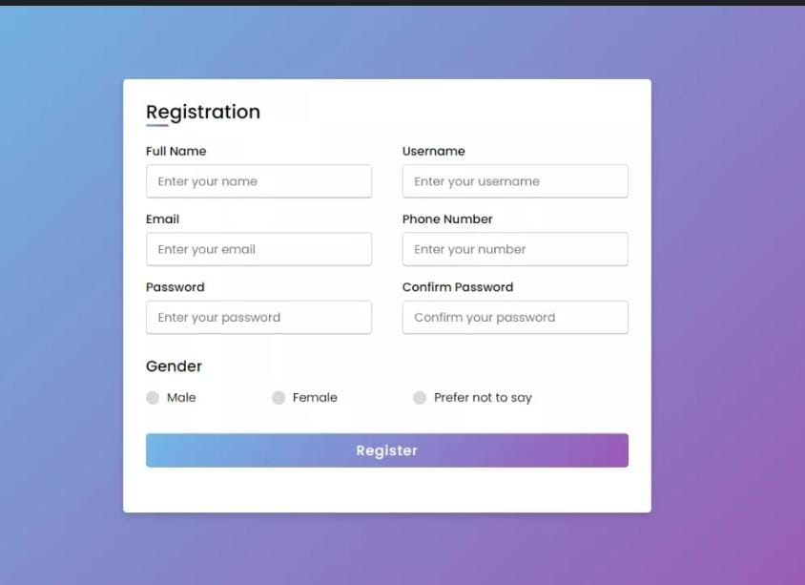

**CHAPTER 4**

**PROJECT BUDGET**

|  |  |  |  |
| --- | --- | --- | --- |
| **Sr. No** | **Cloud Services and Coding Cost** | **Single Price (Rs)** | **Total** |
|  |  |  |  |
|  |  |  |  |
|  |  |  |  |
|  |  |  |  |
|  |  |  |  |
|  |  |  |  |
|  |  |  |  |
|  |  |  |  |
|  |  |  |  |
|  |  |  |  |
|  |  |  |  |
|  |  |  |  |
|  |  |  |  |
| Total | | |  |

**CONCLUSION**

* This registration form is efficient in maintaining student’s details and can easily perform operations on records.
* This project is made in order to replace the manual work.
* This also helps the people using this to save time and money.

Overall improve Efficiency

**CODE**

<!DOCTYPE html>

<!-- Created By CodingLab - www.codinglabweb.com -->

<html lang="en" dir="ltr">

<head>

<meta charset="UTF-8">

<!---<title> Responsive Registration Form | CodingLab </title>--->

<link rel="stylesheet" href="style.css">

<meta name="viewport" content="width=device-width, initial-scale=1.0">

</head>

<body>

<div class="container">

<div class="title">Registration</div>

<div class="content">

<form action="#">

<div class="user-details">

<div class="input-box">

<span class="details">Full Name</span>

<input type="text" placeholder="Enter your name" required>

</div>

<div class="input-box">

<span class="details">Username</span>

<input type="text" placeholder="Enter your username" required>

</div>

<div class="input-box">

<span class="details">Email</span>

<input type="text" placeholder="Enter your email" required>

</div>

<div class="input-box">

<span class="details">Phone Number</span>

<input type="text" placeholder="Enter your number" required>

</div>

<div class="input-box">

<span class="details">Password</span>

<input type="text" placeholder="Enter your password" required>

</div>

<div class="input-box">

<span class="details">Confirm Password</span>

<input type="text" placeholder="Confirm your password" required>

</div>

</div>

<div class="gender-details">

<input type="radio" name="gender" id="dot-1">

<input type="radio" name="gender" id="dot-2">

<input type="radio" name="gender" id="dot-3">

<span class="gender-title">Gender</span>

<div class="category">

<label for="dot-1">

<span class="dot one"></span>

<span class="gender">Male</span>

</label>

<label for="dot-2">

<span class="dot two"></span>

<span class="gender">Female</span>

</label>

<label for="dot-3">

<span class="dot three"></span>

<span class="gender">Prefer not to say</span>

</label>

</div>

</div>

<div class="button">

<input type="submit" value="Register">

</div>

</form>

</div>

</div>

</body>

</html>

**Please Provide Code through Git Hub Repo Link**

https://github.com/PenumechuPavithra